Appendix 16: SWIFT Interview Guide: Engagement




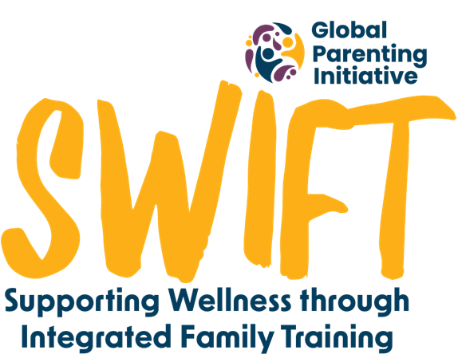


Briefing:

Hi there. Thank you for making the time for this phone call; it won’t take longer than 15 minutes. We noticed that you didn’t finish working through the ParentText programme. We would like to hear a little bit more about your experience, so we can hopefully improve the programme.

We will be recording this phone call, so we can remember your answers, but your name and your answers will be kept confidential and will only be viewed by the research team. After the interview, the recording will be transcribed, or written down, and then it will be deleted. The written down information will be saved securely on a password protected computer. Do I have your permission to record the interview?

There are no right or wrong answers. You can skip any questions you do not feel comfortable answering. You can also stop this conversation at any time if you wish. If you decide at a later stage that you would like your contribution to be removed from the study, you can contact the research team by email until the [date to be determined].

Do you understand what I’ve just explained? Do you have any questions? Can we begin?

- What are the factors that you think led to you not finishing the programme?

- What was your experience of the content?
Probe: Explore relevance of content
Probe: Explore interest in content
Probe: What content could we have added to improve your experience?

- What was your experience of the time and data needed to complete the programme?
Probe for data: Explore the use of Wi-Fi hotspots in the community and what they used to connect to ParentText; explore customisation of content delivery e.g. whether they used audio/visual only.
Probe for time: Explore the amount and timing of messages being sent by the chatbot.

- What was your experience of the home exercises/activities, and do you feel like they impacted whether you finished the programme?

- What do you think about the need for a programme like this to support parents?

- What else can you recommend we do to improve the programme?

Debriefing

Is there anything that we haven’t spoken about that you’d like us to know? If after this conversation, there is anything that causes you to worry, remember you can still access the referral services in the programme by typing ‘help’. SADAG might be a good option. If you have any other questions about the study, you can send us a WhatsApp or email.
We’ve come to the end of our interview. Thanks again for taking the time to speak with us today. Your responses have been very helpful!

